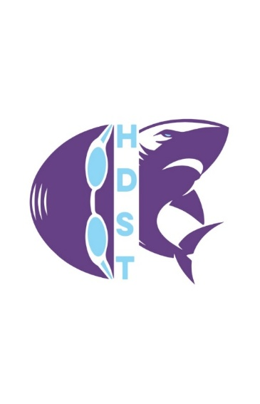
Hi-Desert Swim Team
PO Box 238
Burns, OR 97720
541-573-2413

Job Title: Part-Time Swim Coach
Job Description
The Hi-Desert Swim Team is seeking a reliable and trustworthy Swim Coach to work with athletes ages 6–18. This part-time role involves developing swimmers’ skills, fostering a positive team environment, and preparing athletes for competition. Responsibilities include evaluating swimmers’ abilities, designing age- and skill-appropriate training programs, teaching proper techniques and strokes, and supervising practices. The coach will also assist with meet preparation and may support the Head Coach with travel team activities as needed. This position requires availability for morning and/or evening practices. Practice schedules vary based on group levels and team size, typically ranging from 1 hour in the morning or 1.5–2 hours in the evening. Average commitment is approximately 2 hours per day. Compensation and meet stipends will be determined at the time of hire.
To Apply: Please send your resume to highdesertparkrec@gmail.com. Interviews will be conducted at the next Swim Team Board Meeting.

Key Responsibilities
- Assess swimmers’ skill levels and develop appropriate training plans
- Teach and refine stroke technique, speed, and overall performance
- Instruct swimmers in a variety of strokes and swimming styles
- Build water confidence through structured activities and drills
- Monitor progress and provide constructive feedback
- Set individual and team goals
- Teach essential skills such as turns, kicks, breathing techniques, and body positioning
- Preparing swimmers for meets and competitions

Qualifications
- High school diploma or equivalent
- Prior swim coaching or instruction experience preferred
- Relevant certifications (e.g., lifeguard, swim instruction) and ability to pass a background check
- Strong understanding of swim techniques and training methods
- Excellent organizational, communication, and interpersonal skills
- Ability to work with a wide range of ages and skill levels
- Positive attitude and team-oriented mindset

What Makes a Great Coach
Successful candidates are patient, encouraging, and adaptable to varying skill levels. The best coaches emphasize personal growth, technique, and effort while motivating swimmers to reach their full potential.

