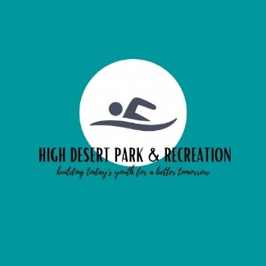

FOR IMMEDIATE RELEASE: 2-6-2023
Contact: Brandy Branstetter/District Manager
Phone:(541)573-2413
Email: Highdesertparkrec@gmail.com

Upcoming Election for High Desert Park and Recreation:

There are 4 board positions open for elections on the High Desert Park and Recreation Board of Directors. After the election, two seats will fill a 4 year term to begin on July 1st, 2023 and end on June 30th, 2027, the additional two seats open will serve a 2 year term to begin on July 1st, 2023 and end on June 30th, 2025.

The High Desert Park and Recreation Board of Directors is comprised of 5 board members. Each member is elected by the registered voters of the district to serve a 2 or 4 year term. Interested candidates must be registered voters who reside within the district’s boundaries.

Interested candidates can request an information packet, which includes information about the district and position, from the district office. Please contact Brandy Branstetter at (541) 573-2413, email highdesertparkrec@gmail.com, or visit our local office located at 763 Ponderosa Village during regular business hours.

To run for election, please contact the Harney County elections office located within the Harney County Court House for more information. For more details about district elections, download a copy of the Elections Manual at https://sos.oregon.gov/elections/Documents/county-city-district-candidates.pdf. Pages 23 and 24 are most relevant.

About: High Desert Park and Recreation

HDPR serves the Burns and Hines city areas and was formed in 1969. It provides youth and adult recreational activities such as Soccer, Middle School Travel Soccer Team, Youth Football travel league, Boys and Girls Basketball, Volleyball, Adult Softball, and Men’s League Basketball. We hold events open to our community such as Roller Skate Nights, Father/Daughter Dance and Cornhole Tournaments. Camps for youth are available through out the summer months that include Tennis camp, various soccer camps, and a cheer camp. HDPR also manages our beloved seasonal swimming pool, tennis courts and basketball court located at Anderson Park. Future goals for HDPR would be to upgrade and rehabilitate the pool and tennis court, potentially a sports complex designated for park and recreation, and build our current leagues with continued community involvement.

